# Name: Basil Ahamed

# PostgreSQL Assignment

### **Assignment Description**

In this assignment, you will work with PostgreSQL, a powerful open-source relational database management system. Your task involves creating 03 tables based on the provided sample data and then writing and executing queries to perform various database operations such as creating, reading, updating, and deleting data. Additionally, you will explore concepts like LIMIT and OFFSET, JOIN operations, GROUP BY, aggregation and LIKE.

## **Instructions:**

### **Database Setup:**

* Create a fresh database titled **"university_db"** or any other appropriate name.

Image:

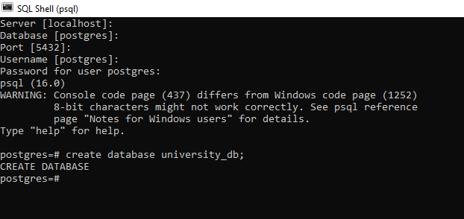

## Table Creation:

Create a **"students"** table with the following fields:

* student_id (Primary Key): Integer, unique identifier for students.
* student_name: String, representing the student's name.
* age: Integer, indicating the student's age.
* email: String, storing the student's email address.
* frontend_mark: Integer, indicating the student's frontend assignment marks.
* backend_mark: Integer, indicating the student's backend assignment marks.
* status: String, storing the student's result status.

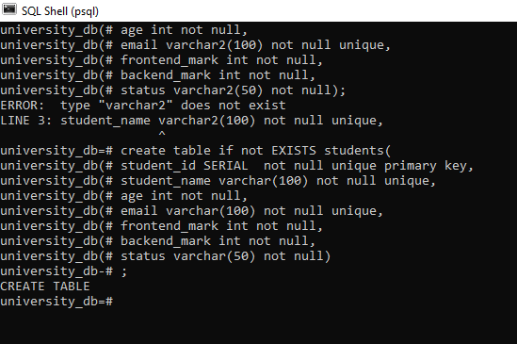

Create a **"courses"** table with the following fields:

* course_id (Primary Key): Integer, unique identifier for courses.
* course_name: String, indicating the course's name.
* credits: Integer, signifying the number of credits for the course.

Create an **"enrollment"** table with the following fields:

* enrollment_id (Primary Key): Integer, unique identifier for enrollments.
* student_id (Foreign Key): Integer, referencing student_id in "Students" table.
* course_id (Foreign Key): Integer, referencing course_id in "Courses" table.

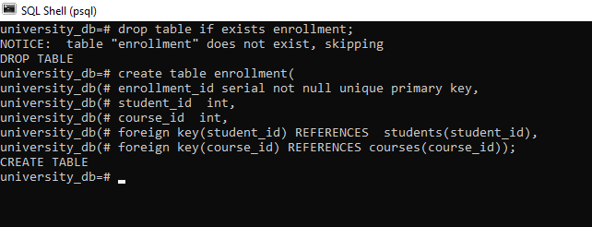

## Sample Datas

* Insert the following sample data into the **"students"** table:Insert the following sample data into the **"courses"** table:

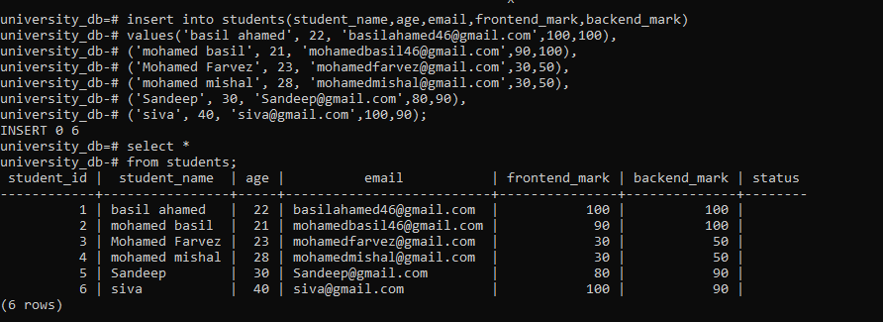

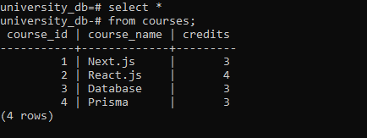

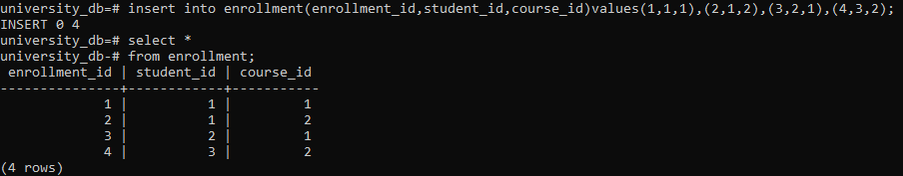

## **Execute SQL queries to fulfill the ensuing tasks:**

### **Query 1:**

Insert a new student record with the following details:

* Name: YourName
* Age: YourAge
* Email: YourEmail
* Frontend-Mark: YourMark
* Backend-Mark: YourMark
* Status: NULL

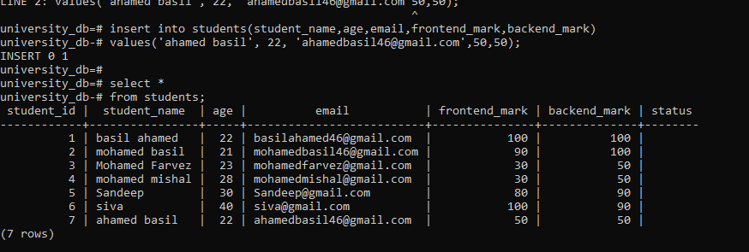

### Query 2:

Retrieve the names of all students who are enrolled in the course titled 'Next.js'.

### 

### Query 3:

Update the status of the student with the highest total (frontend_mark + backend_mark) mark to 'Awarded'

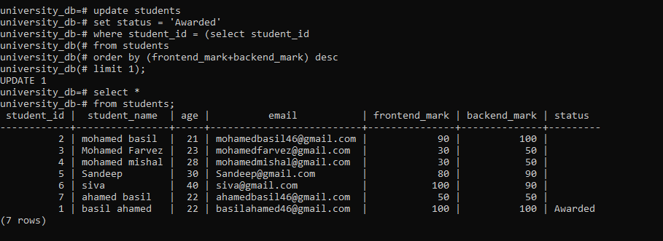

### Query 4:

### Delete all courses that have no students enrolled.

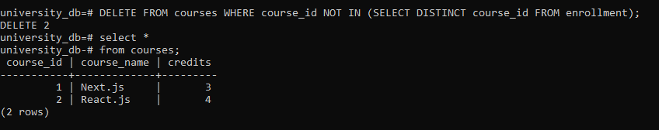

### Query 5:

Retrieve the names of students using a limit of 2, starting from the 3rd student.

### 

### Query 6:

Retrieve the course names and the number of students enrolled in each course.

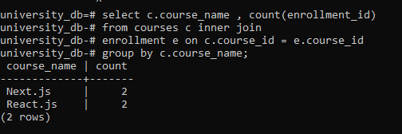

Query 7:

Calculate and display the average age of all students.

### 

### Query 8:

Retrieve the names of students whose email addresses contain 'example.com'.

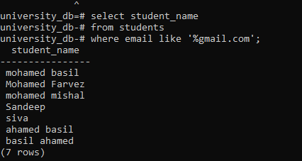

Final_output_description

Prepare the SQL code for table creation, sample data insertion, and the seven queries in a text document or your preferred format. Include comments explaining each query's purpose and functionality. **Save your document as "PostgreSQL_Assignment.sql" or any other appropriate name.**

**Based on the above table data explain the concept along with the example for below items**

1. **Explain the primary key and foreign key concepts in PostgreSQL.**

primary key is used to find the uniquely from the table and foreign key is used to established the connection between the two tables

1. **What is the difference between the VARCHAR and CHAR data types?**

| **Varchar** | **Char** |
| --- | --- |
| varchar datatype contain all characters | char datatype also contain all characters |
| varchare variable length allocation | Char datatype use fixed length allocation |

1. **Explain the purpose of the WHERE clause in a SELECT statement.**

**Where**:

where clause is used to filter the records and it was execute row by row

**select:**

select clause is used to display the records according to the conduction

1. **What are the LIMIT and OFFSET clauses used for?**

**Linit**:

limit is used to give the limited rows according to number you enter

**Offset**:

offset is used for which row you want to start the record data

1. **How can you perform data modification using UPDATE statements?**

**Syntax**:

update table_name

set colomn_name = “values”

(or)

update table_name

set coloum_name = “values”

where conduction

1. **What is the significance of the JOIN operation, and how does it work in PostgreSQL?**

**in postgresql we have joins**

* inner join
* left outer join
* right outer join
* full outer join
* cross join
* self join

1. **Explain the GROUP BY clause and its role in aggregation operations.**

group by clause is used to group the records according to the column name and aggregation function for the example we can use the avg() function to aggregation function

1. **How can you calculate aggregate functions like COUNT, SUM, and AVG in PostgreSQL?**

syntax:

select count(*), avg(age), sum(age)

from students;

1. **What is the purpose of an index in PostgreSQL, and how does it optimize query performance?**

An index in PostgreSQL is a database object that improves the speed of data retrieval operations on a table at the cost of additional storage space and decreased performance on data modification operations.

1. **Explain the concept of a PostgreSQL view and how it differs from a table.**

A **view** in PostgreSQL is a saved SQL query that you can treat as if it were a table. It is a virtual table derived from one or more tables or other views. Unlike a table, a view does not store data physically.